**Planty Bot v.2 Building Logic**

Demo video: https://drive.google.com/file/d/1Pqm6aS5IHIIecwT3JiY2JOI2CJu8_f38/view?usp=sharing

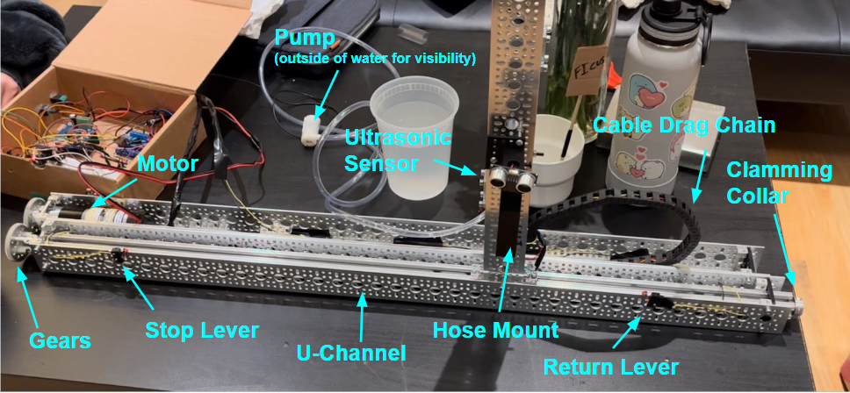

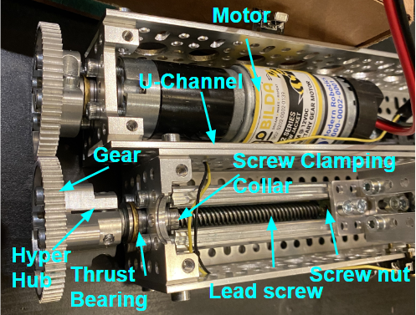

**- *Function-critical calculations*:**

*Gear Load*:

*Torque required to move the body through the thread*:

, where is the force applied to each gear teeth, is the coefficient of static friction between the gears, is the diameter of the gears, and is the length of the thread.

. This torque value will produce a force value of 300 N on the lead screw threads, which won’t bend/break the threads.

The lead screw thread gives 8 mm of linear movement per rotation. By experimentation, we get a result of a linear velocity of 8 mm per 1.5 seconds. Therefore, we get 1/1.5 = 2/3 revolutions per second.

, where this value is the result of maximum voltage of 12 V.

**- *Circuit and State-Transition Diagrams*:**

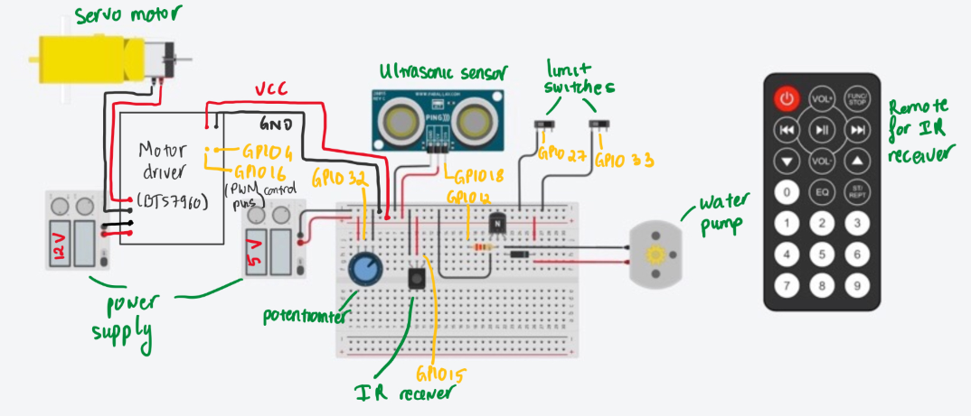

*Circuit Diagram*

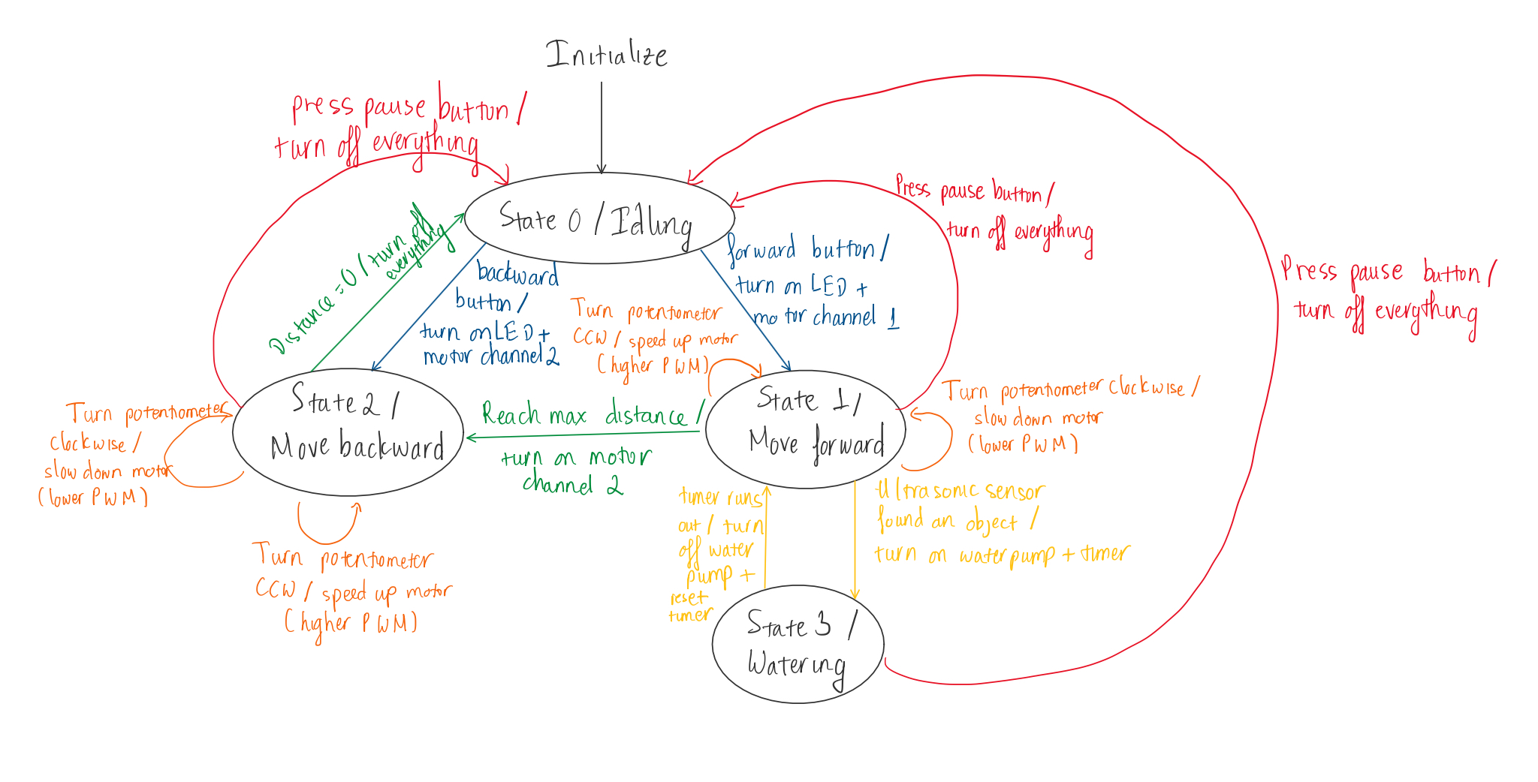

*State-Transition Diagram*

***Images of the CAD***:

